OneTech ’02 Technical Symposium – 17 November 2002
Canberra, Australia
Darryl Smith, VK2TDS

http://www.vk1.wia.ampr.org/OneTech'02/index.html

For those that are not familiar with the Australian callsign designations, VK1 is the small region of about 300,000 people called the Australian Capital Territory, the Australian equivalent of the District of Columbia. Our national capital, Canberra, is the city within this area of 55 miles x 45 miles wide, of which over half is nation park bordering Australia's snowfields. It is also known for having one of NASA's three deep space tracking stations, known locally by its Australian Aboriginal name, Tidbinbilla. www.cdscc.nasa.gov

I live a bit over two hours drive away near the city of Sydney in New South Wales state also known as VK2 - with a population of 5 million people - that surrounds VK1.

The OneTech event is an annual event down in VK1 with aims similar to the DCC held in the USA each year, albeit on a smaller scale. See www.vk1.wia.ampr.org. Rather than taking place over three days, OneTech is a full Sunday of talks and presentations on any technology that might be of interest to those attending. The Wireless Institute of Australia (WIA) which puts on the event is the oldest wireless organisation in the world. Being a regional conference, the attendance at the conference was smaller than you would expect at a DCC - but not by much.

I was at OneTech for two reasons. I was asked to talk about 802.11 in ham radio months before the event, and since a speaker dropped out I also spoke giving a 45 minute overview of the DCC in Denver, Co. Interestingly the speaker who dropped out was talking about Australia’s first home-grown satellite since Oscar 5.

RS-485 in the shack

One of the Ah-Ha moments for me was hearing a talk by Kerry VK1KRF
(http://www.qsl.net/vk1krf/) about RS-485 in the shack using PIC processors. This sparked my interest - that maybe this should be an area that TAPR looks at. He has an antenna rotator with RS-485 control - made from an old security camera Pan and Tilt head from the USA Embassy in Canberra. He also had general input and output devices, DTMF decoders - everything. He has even built a computer controlled phasing harness.

His view is that if it moves, put a US$1 processor on it with RS-485. One pair of wires with the addition of power and ground does it all. And the front end can be programmed in Visual Basic. VB also handles contention for the Comms port.

It is amazing to see what Kerry has achieved - and it is so logical. The core to what he has done is a small amount of serial programming dealing with differential signaling, with a very simple parser. Kerry decided that every device would have its own address, and be accessed with short ASCII commands. Simple but Effective.

Make Ham Radio Illegal

Australia's most famous Ham, Dick Smith VK2DIK (who I am not related to
unfortunately) flew in literally for a few hours. Dick made his fortune with the Dick Smith Electronics (www.dse.com.au) stores that he sold years back, but which are now as popular as Radio Shack, but more technical.

His three books on basic electronics have been required reading in Australia for years for teenagers and slightly younger. Last I checked one of the volumes was in it's 23rd printing

What makes Dick unique is that he is an Adventurer: He was the first person to fly a Helicopter around the world, in the early 1980s, taking a new Bell Jet Ranger from the factory. His means of communication was Ham Radio! He was also the first person to fly a helicopter to the north pole, during a round the world flight to both poles. He later headed the Civil Aviation Safety Authority for a time - which most people believe was a total disaster.

Dick made comment that when he got CB Radio legalized in Australia, sales went almost to zero overnight. Seems that teenagers were buying the units because they were illegal. He suggested that if you make Ham Radio illegal - or at least the HF bands - then you will attract the young people back.

He commented that he thinks that adventurers will soon be doing events without Iridium phones and GPS receivers so that they can bring the challenge back. Dick also commented that during a storm flying solo across the Atlantic he rang his wife from his Iridium phone to her cellphone. He thought she was in Sydney, but was really in Saks 5th Avenue in New York. He commented at not really needed Ham Radio to keep in contact when that sort of thing is possible.

BushLan

One of the other talks was from the Australian National University on BushLAN - Using low frequency television spectrum to connect regional Australia to the Internet. Basically this is a University project that has got some significant press in Australia thanks to a broadband enquiry.

It involves putting high speed packet radio gear on 70 MHz and using it for the last '5-10 Miles' that tends to be the issue in Australia. [Here in Australia we have people who own more land than New York state, and have less than 100 people living on it. Guess how far the nearest telephone exchange is.

More information on BushLan can be found at wwwrsphysse.anu.edu.au/BushLAN/

TAPR Activities

TAPR were given the opportunity to not only promote ourselves at the talks, and give out membership forms, but also to donate a prize - a copy of Wireless Digital Communications by Tom McDermott - to be awarded for Technical Excellence to Peter VK1NPW. Peter has been pivotal to getting APRS going in VK1, including several Wides and an IGate. He is well respected for 'getting his hands dirty' with radio technology, and in practice. The local hams are heavily into providing radio communication for car rallies, as 'emergency communications' exercises, and Peter recently instrumented 6 cars during a rally as an APRS exhibition to the organizers and fellow hams.

In this photo, the busy organizer, Peter Ellis VK1KEP, presents the prize to Peter Westerhoff VK1NPW.

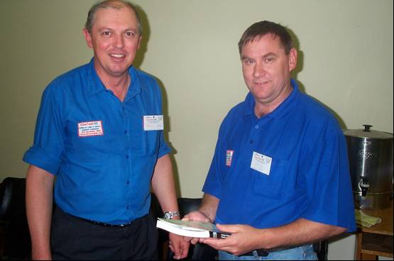

TAPR awarded a runner up award of a DCC Proceedings to one of the members of BushLAN so that they could learn about what TAPR is doing, and hopefully a journal that they can publish some of their research in. This is particularly important since the BushLAN people are not generally Hams and are not familiar with how we can support them.

Lastly, one of the local HAMS was presented with a book on Programming PIC Processors from my personal collection so that he could try something new.

