Radioactive Networks



Communications Options for a Repeater Site

POBox 169
Ingleburn NSW 2565 Australia
Phone: 0412 929 634 – International +61 412 929 634
(Registered Office: 23 Amanda Place, Ingleburn 2565)
www.radio-active.net.au - Darryl@Radio-active.net.au

Communications Options for the Site

This document is being written following discussions with the site ownert.

Following these discussions I believe that a solution can be implemented for under $10,000, subject to cabling and mounting considerations.

Options such as Fibre Optic have not been included in this document since they have not been fully investigated. Radioactive Networks are able to install Fibre Optics if required, as our staff hold ACA accreditation for communications wiring, and have been trained in all aspects of Fibre Optic cabling.

Wireless Network Connection

Using 802.11 technology, it is possible to extend a network between two locations without a significant expenditure. Using this technology should allow a link with a guaranteed throughput of over 2 mBit/sec, whilst using 112 bit encryption.

Proposed Solution

- 802.11 Wireless Network connection between the upper and lower stations at Kangaroo Valley.
- Repeater Station installed on the surge tank
- Possible use of Solar Power for the repeater

Details

Lower Site

The lower Site has good line of site to the surge tower form much of the building. Line of sight should be possible from just outside the admin offices where the existing communications links are terminated.

Placing a wireless station would require mounting an antenna radio modem unit on the outside wall of the station pointing to the surge tower and using Cat-5 cable to the Communications Cabinet. It would be ideal if power could be supplied direct to the radio modem, but the power supply could be supplied over Ethernet without any difficulty

Surge Tower Repeater

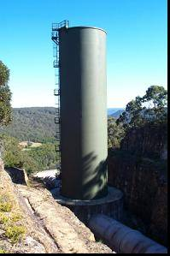
I am proposing placing a repeater on the top of the surge tower with antennas pointed towards both stations, powered with Solar Power. This would require a 50-75mm pole being mounted on the top of the surge tower to mount the solar panels, antennas and repeater unit

There are some issues regarding the provision of the pole, to allow safe working, so that it can be lowered slightly for maintenance.

I am proposing placing a 60 Watt solar panel with lead acid battery on the tower. This will support a half-duplex repeater, limiting throughput to a maximum effective rate of 3.5 mBit/seconds. Placing another solar panel and radio modem will allow this to be doubled.

The repeater would have enough battery capacity for about 72 hours without any sunshine. The proposed solar cell can supply a peak of 60W, and the repeater requires under 3, giving ample available generation capacity, even on the worst days in the middle of winter.

Should it be found that the battery capcity is insufficient it would be possible to add another battery without problems.

Upper Site

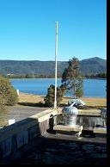
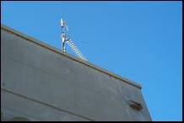
A similar mounting to the lower station is required for the upper station. It appears that line of sight might be possible from the lower roof of the building. A possible location for the equipment would be attached to the old flag poll on the building. This would be good since it is designed to be lowered for maintenance.

Wiring should be simple. Other antennas are wired by simply passing the cable out a window. This would be possible in this case. There are some antennas on top of the upper roof. This would also be a possible location for the equipment.

Site Survey

In order to verify that this solution will work a site survey will be required. This will require placing a temporary unit on top of the surge tower and upper station. This will verify that an RF path exists between the upper station and the surge tower.

During the site survey is when mounting and cabling requirements would be fully defined.

Visualization

The accompanying photos are what a system could look like. These photos were from an applications note. An eventual implementation would be built to better engineering principles.

In an implementation the antennas would still be a sealed design, but they would be more directional than the ones shown. In the first photo the antennas are left and center with the repeater on the right.

Please Note: These two pictures are from a repeater design I found on the internet. They approximate how we would implement such a repeater.

